|  |  |
| --- | --- |
| **https://lh7-us.googleusercontent.com/cqr1zywKLZ-KYtGHQsJs_4r0Pz65g7Hm9cYAB_QVFrqm6JK4FqjMzqYGew6RHuFzmfT56Wdn2C69ISfHmuDwuy_tnadpQXO2ujqRH_tBzkPaOHrK6awj4voQaDIwnQBQeNfh8u1bi15aREV24NpZmw** | **Compiler Construction**  **BSCS 5-A**  **Department of Computer Science**  **Bahria University, Lahore Campus** |

**Assignment: [1]**

Date: Week 4, March 2024

Name: _AFFAN AHMAD_____

Roll No:  _03-134221-003____

|  |  |  |  |
| --- | --- | --- | --- |
| **Evaluation of CLO** | **Question Number** | **Marks** | **Obtained Marks** |
| **CLO1:  Understand the basic techniques used in compiler construction.** | 1 | 5 |  |
|  |  |  |
| **Total Marks** | | **5** |  |

**Q1: Consider set of instruction involved in computation of Fibonacci sequence.**

1. **Design and Analyze the DFA for Fibonacci Series that generates the first five numbers of the Fibonacci series**
2. **Describe each state and the transitions between states.**
3. **Draw state transition table and a conceptual diagram of the DFA.**

**Avoid plagiarism.**

**The assignment is supposed to be written individually, similarity in assignment will lead to 50% deduction in obtained marks.**

Start (S): Initial state where the DFA starts.

First (F1): Represents the first number in the sequence, which is 0.

Second (F2): Represents the second number in the sequence, which is 1.

Third (F3): Represents the third number in the sequence, which is the sum of the first two numbers.

Fourth (F4): Represents the fourth number in the sequence, which is the sum of the second and third numbers.

Fifth (F5): Represents the fifth number in the sequence, which is the sum of the third and fourth numbers.

**Transitions:**

From Start (S), there is a transition to First (F1).

From First (F1), there is a transition to Second (F2).

From Second (F2), there is a transition to Third (F3).

From Third (F3), there is a transition to Fourth (F4).

From Fourth (F4), there is a transition to Fifth (F5).

**State Transition Table:**

| State | Input 0 | Input 1 |
| --- | --- | --- |
| S | F1 |  |
| F1 |  | F2 |
| F2 | F3 |  |
| F3 |  | F4 |
| F4 | F5 |  |
| F5 |  |  |
|  |  |  |

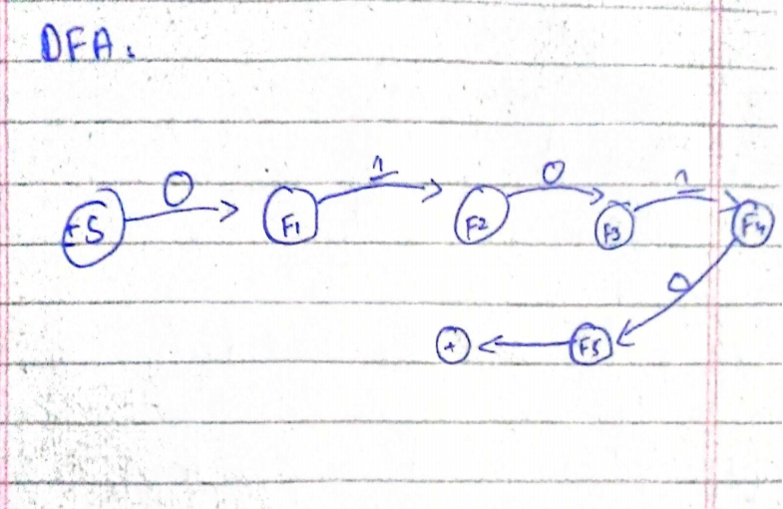

This DFA will generate the first five numbers of the Fibonacci series when provided with inputs 0 and 1 alternately.